

**Lakwimana App**

**Lab 06**

SE3050 – User Experience Engineering – 2021

Group ID: 2021S1_REG_WE_39

Submitted by:

1. IT19101620– (Salika Madhushanka W.J)
2. IT19129372– (H.H.W.M.Binuka Sihan Paranagama)
3. IT19240152– (Umesh Ranthilina K.M)
4. IT19117256– (P.Y.D Jayasinghe)

2021.09.13

**Table of Contents**

1. Sketching 3

2. Wireframes 10

3. Prototype (Version 1.0) 14

3. User Feedback 18

3.1 User Test Script – 01 18

3.2 User Test Script – 02 19

3. Prototype (Version 2.0) 20

**1.** **Sketching**

**1.1 IT19101620 -** Salika Madhushanka W.J

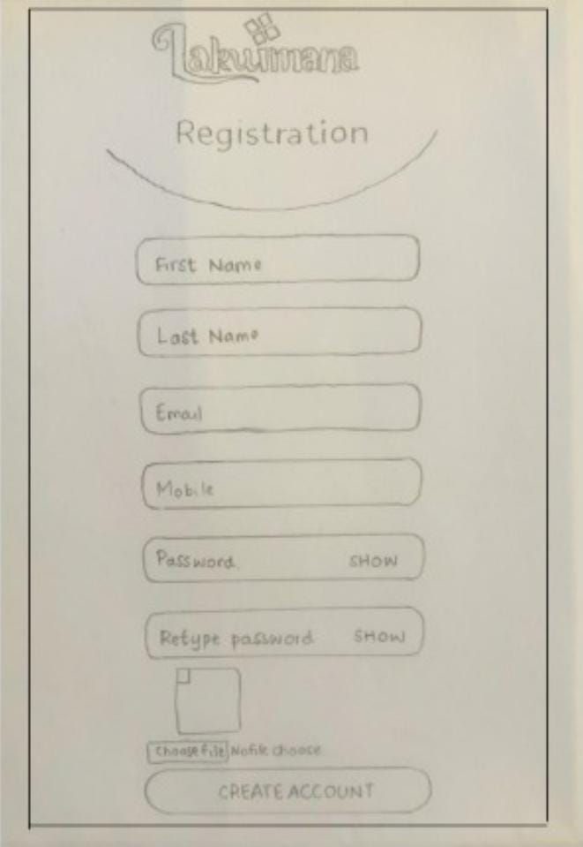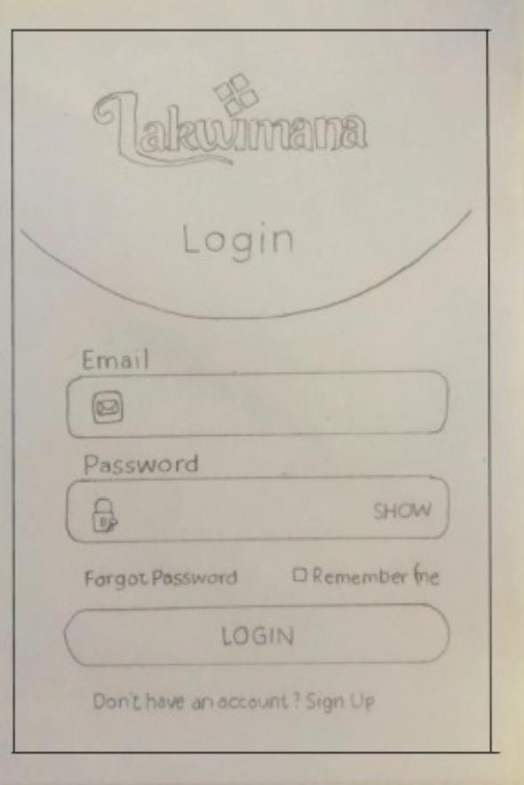

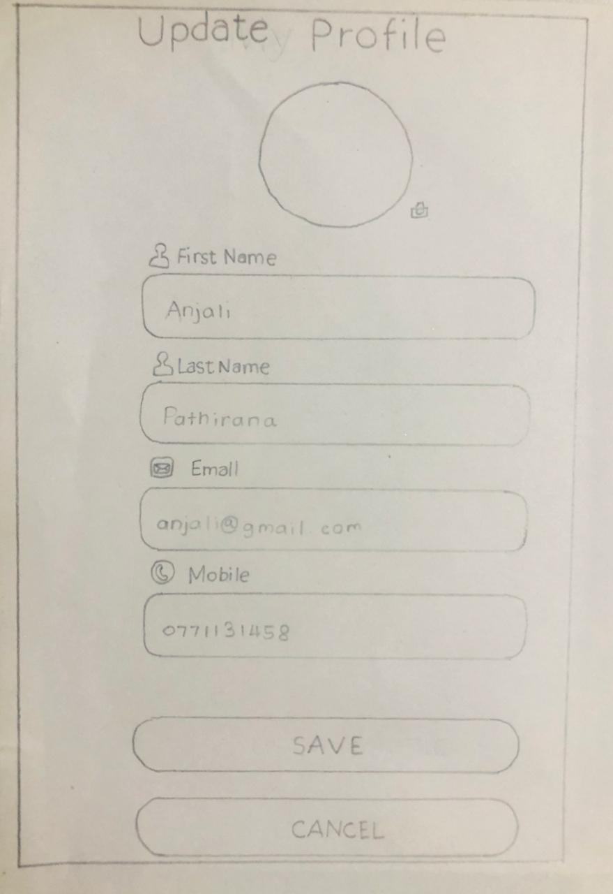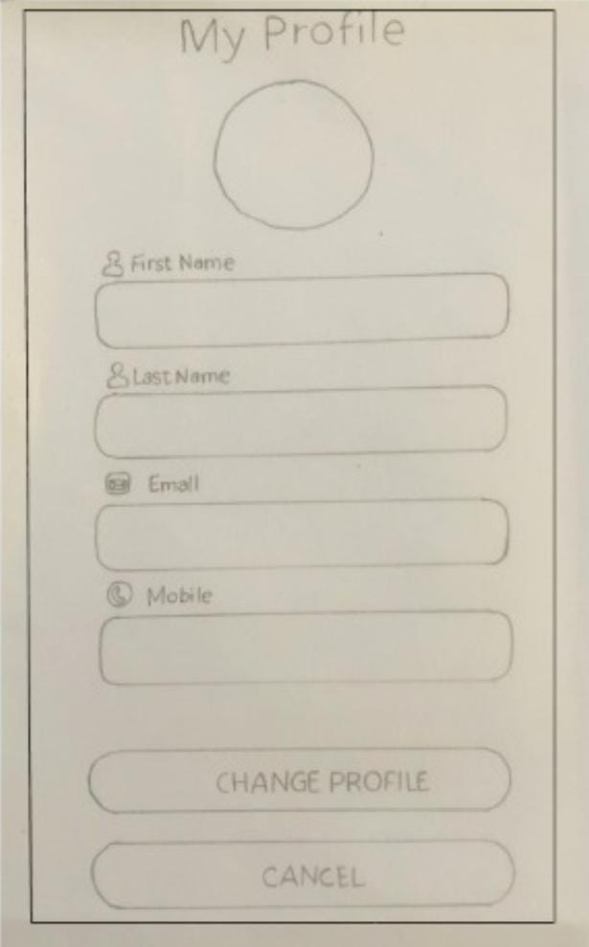

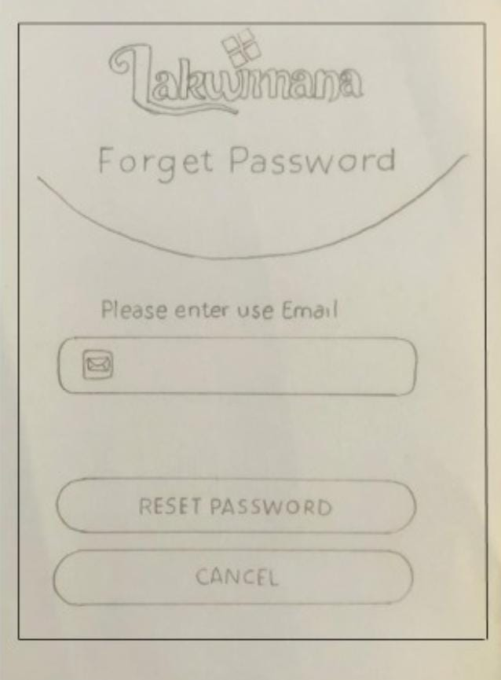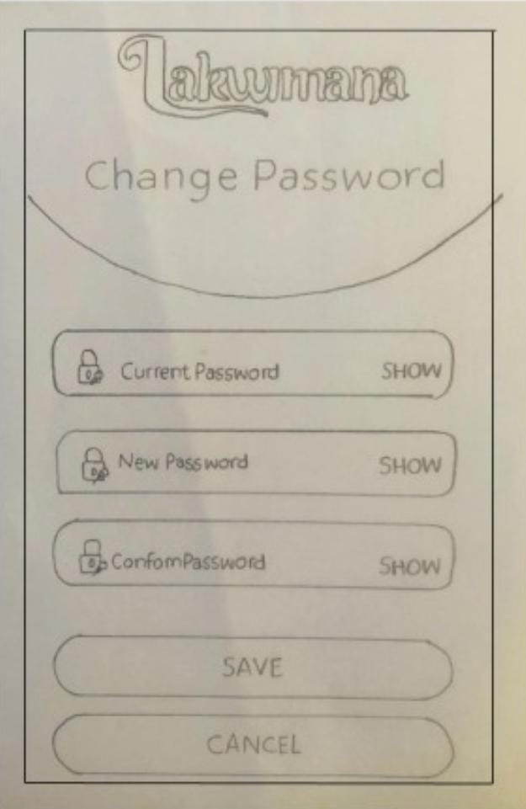

**1.2 IT19117256-** P.Y.D Jayasinghe

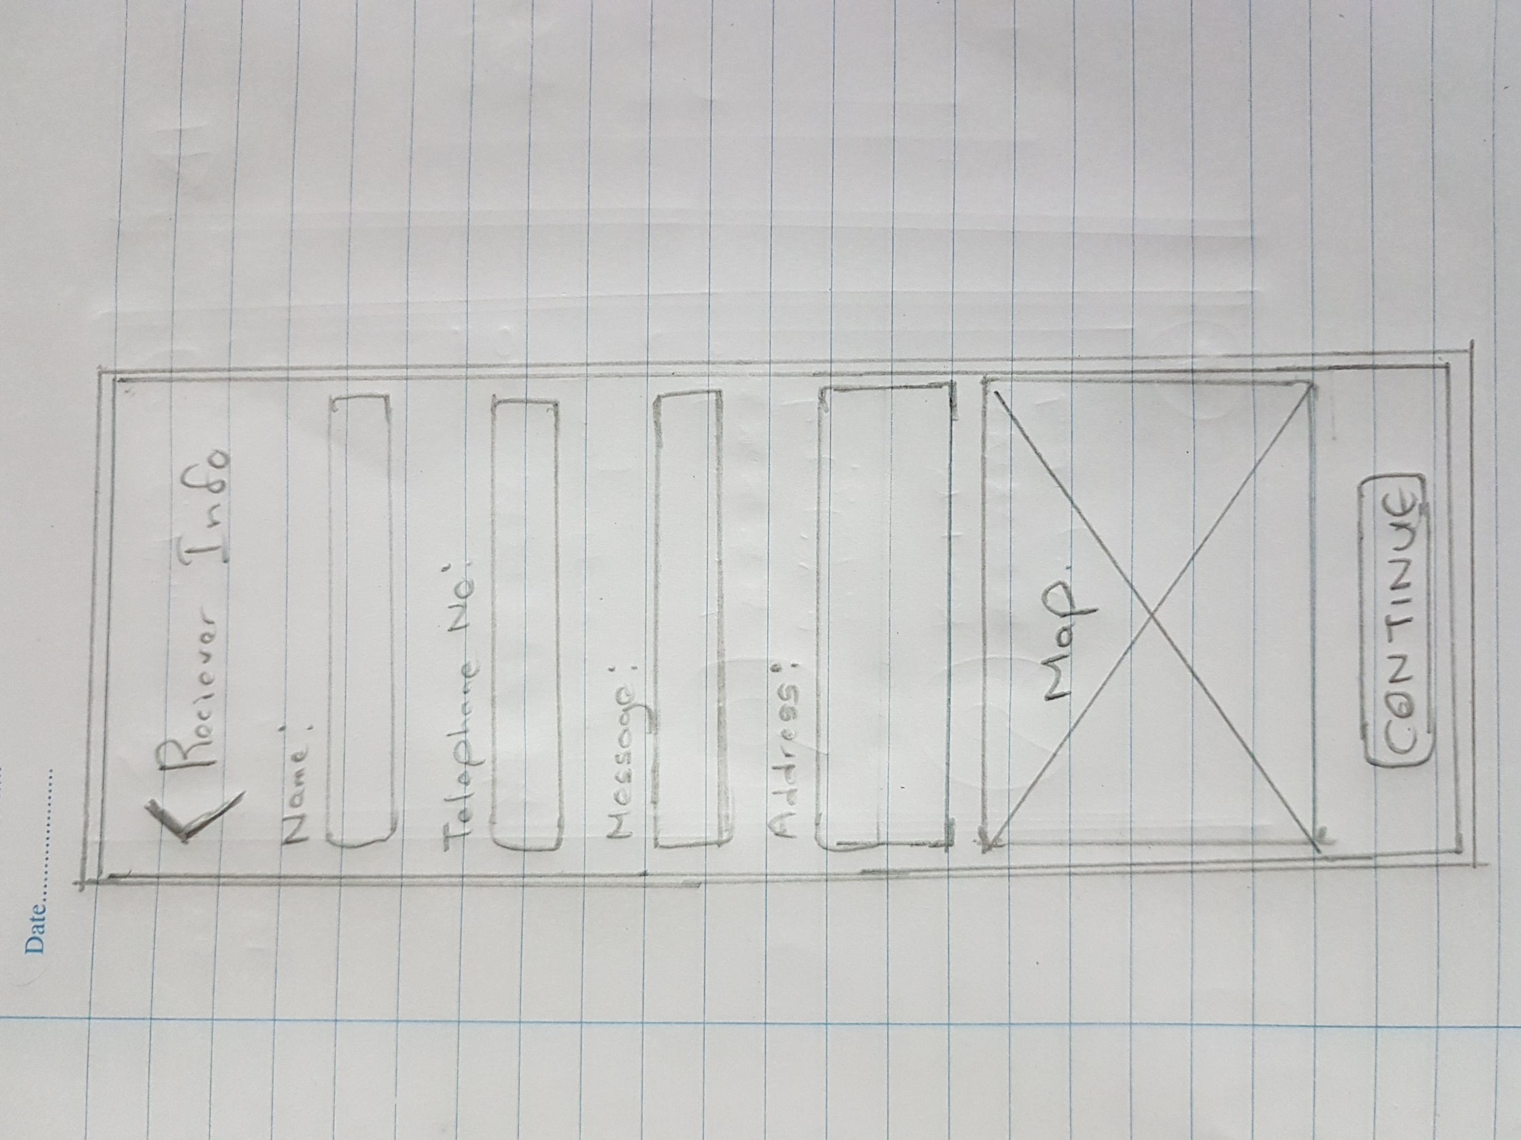

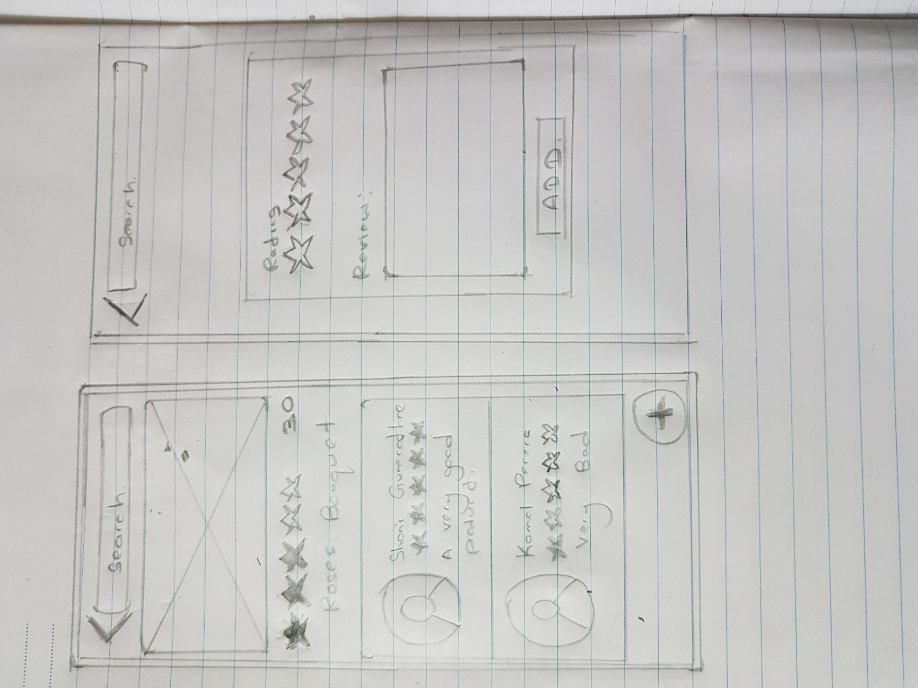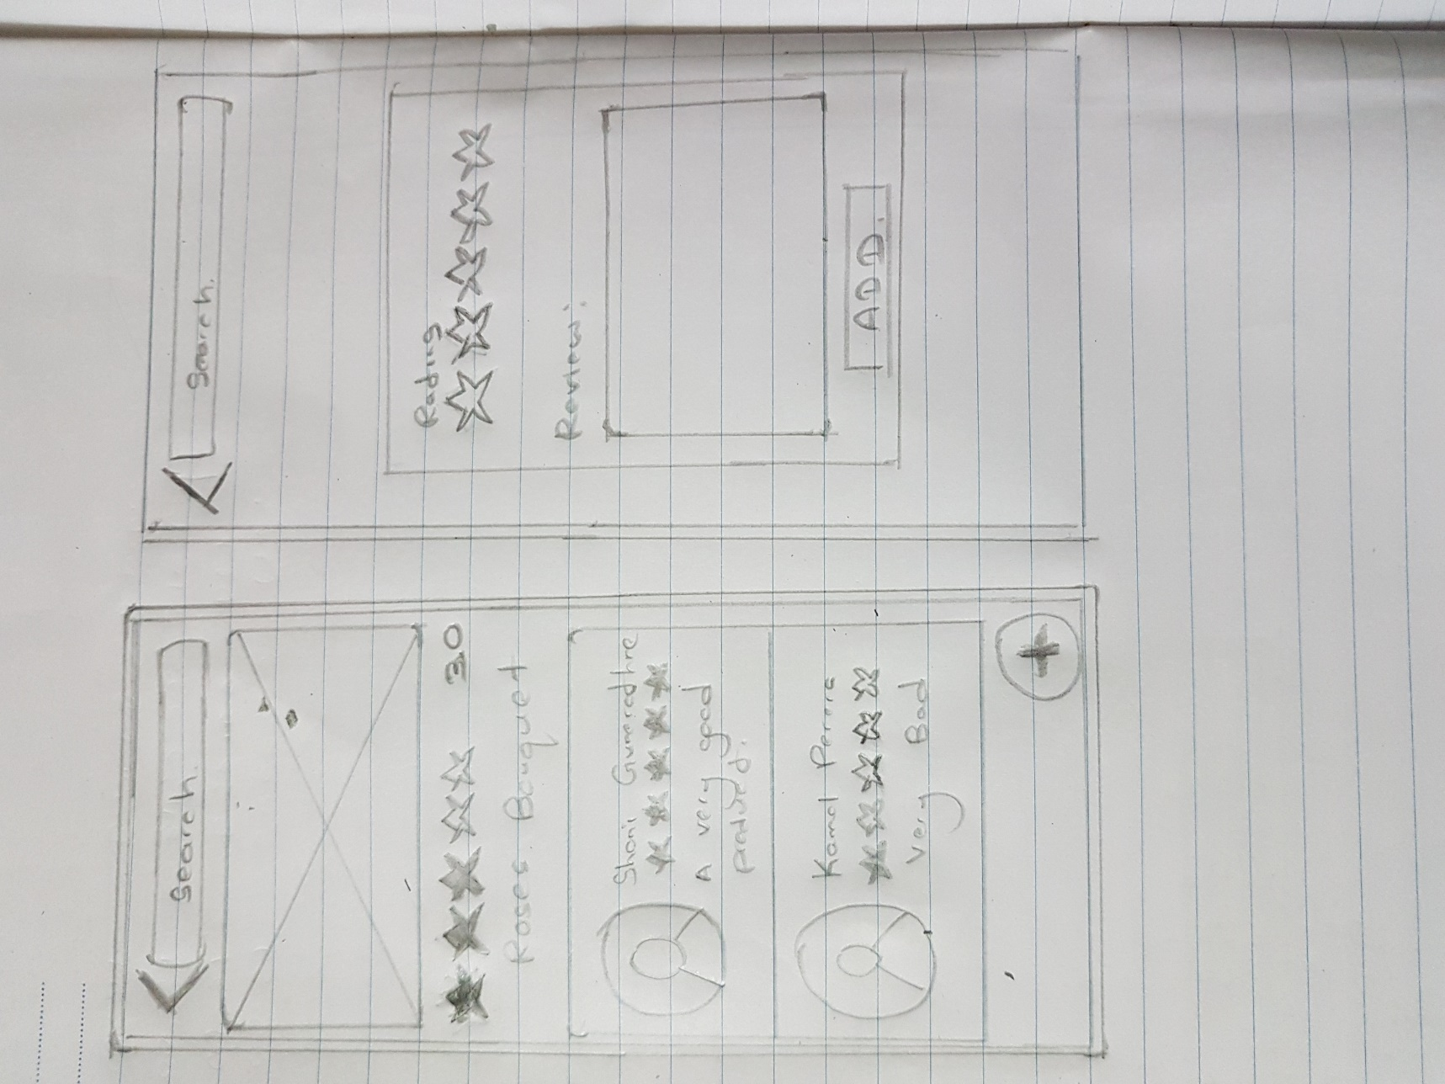

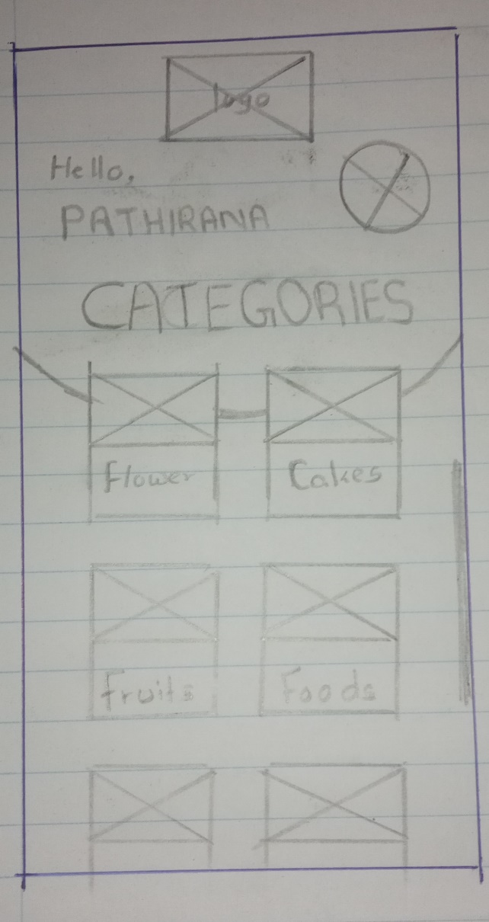**1.3 IT19240152-** Umesh Ranthilina K.M

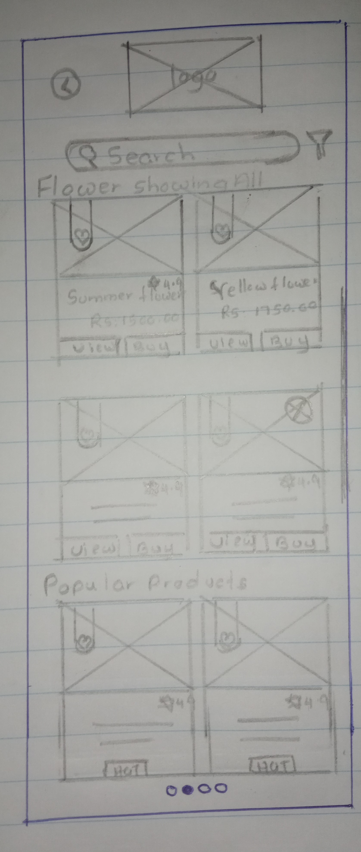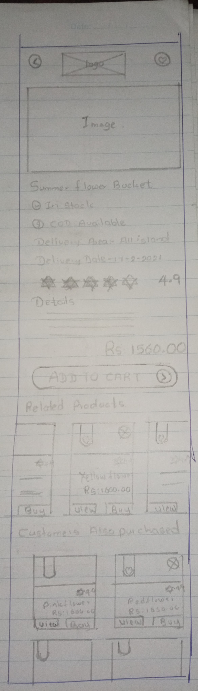

**1.4 IT19129372-** H.H.W.M.Binuka Sihan Paranagama

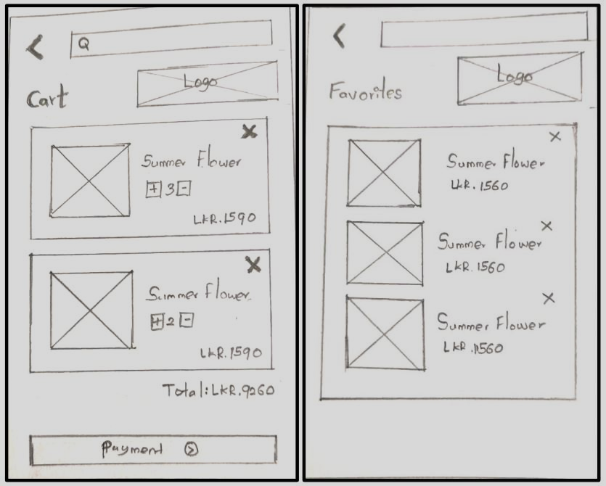

**2.****Wireframes**

**2.1 IT19101620 -** Salika Madhushanka W.J

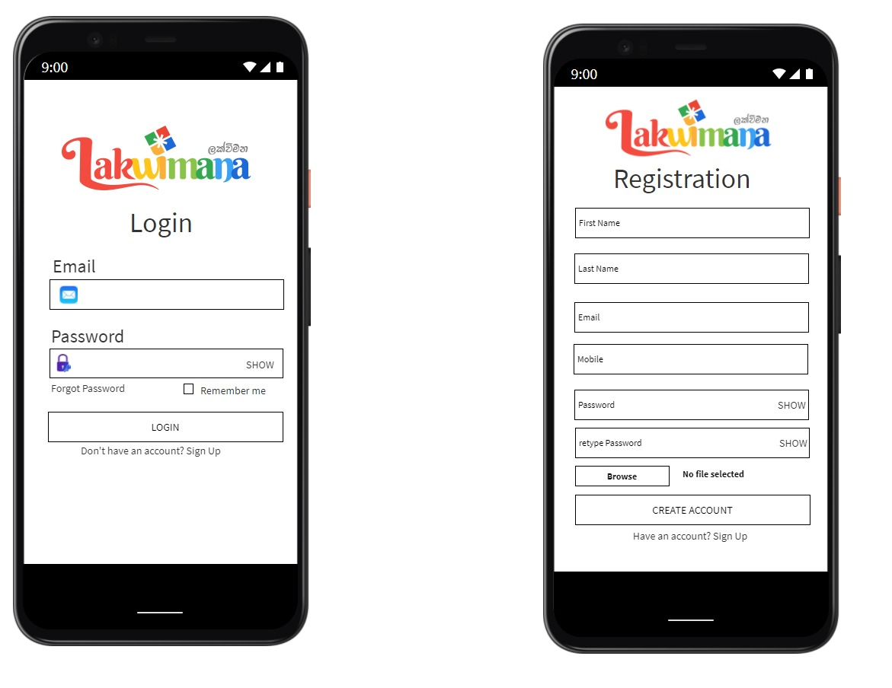

**2.2 IT19117256-** P.Y.D Jayasinghe

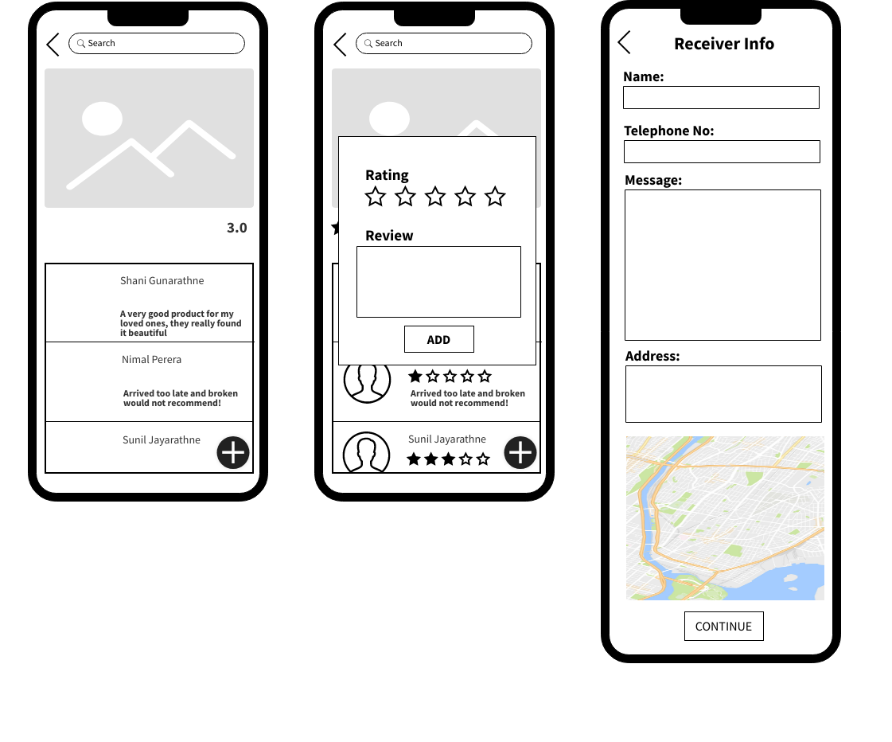

**2.3 IT19240152-** Umesh Ranthilina K.M

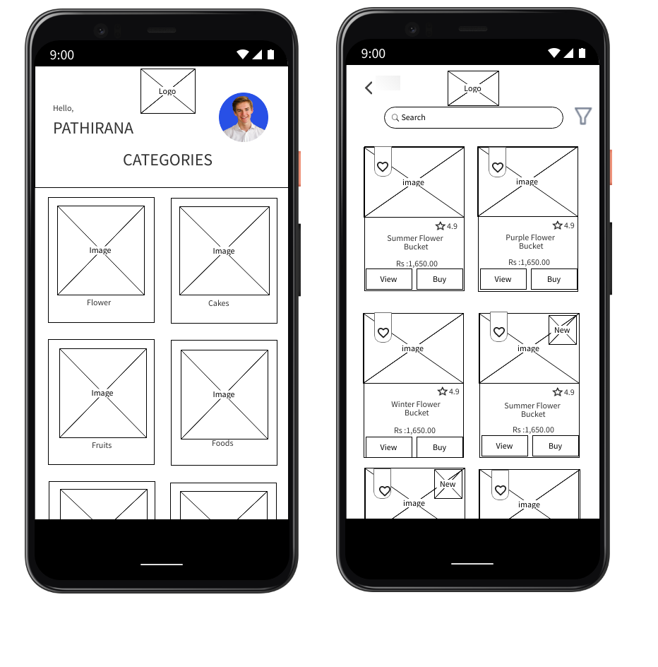

**2.4 IT19129372-** H.H.W.M.Binuka Sihan Paranagama

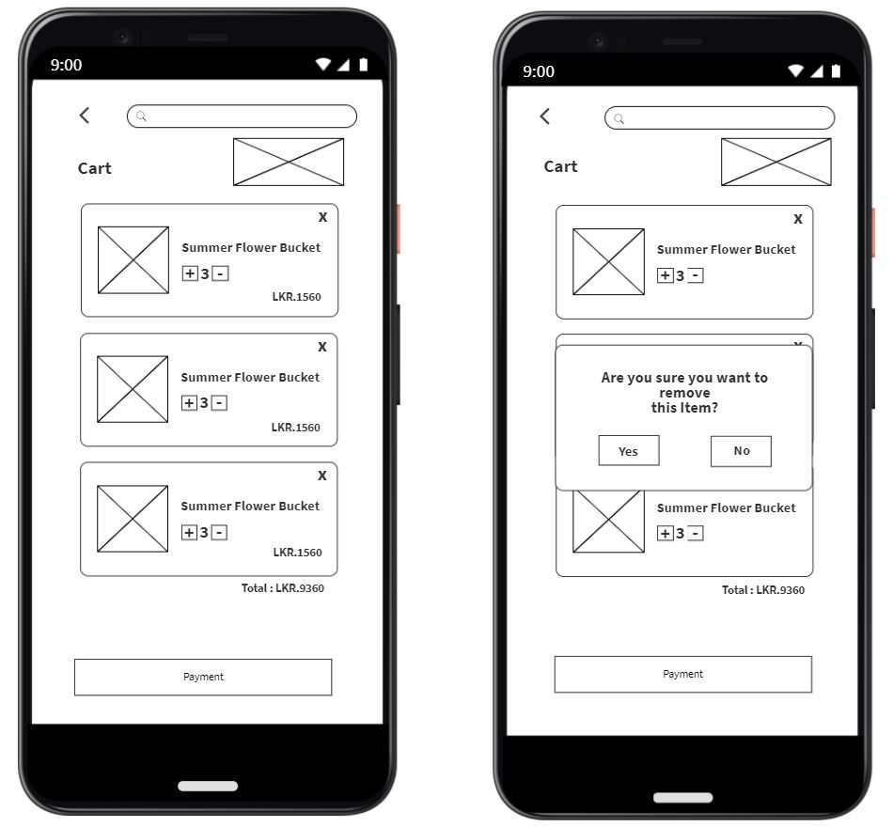

**3.** **Prototype** (Version 1.0)

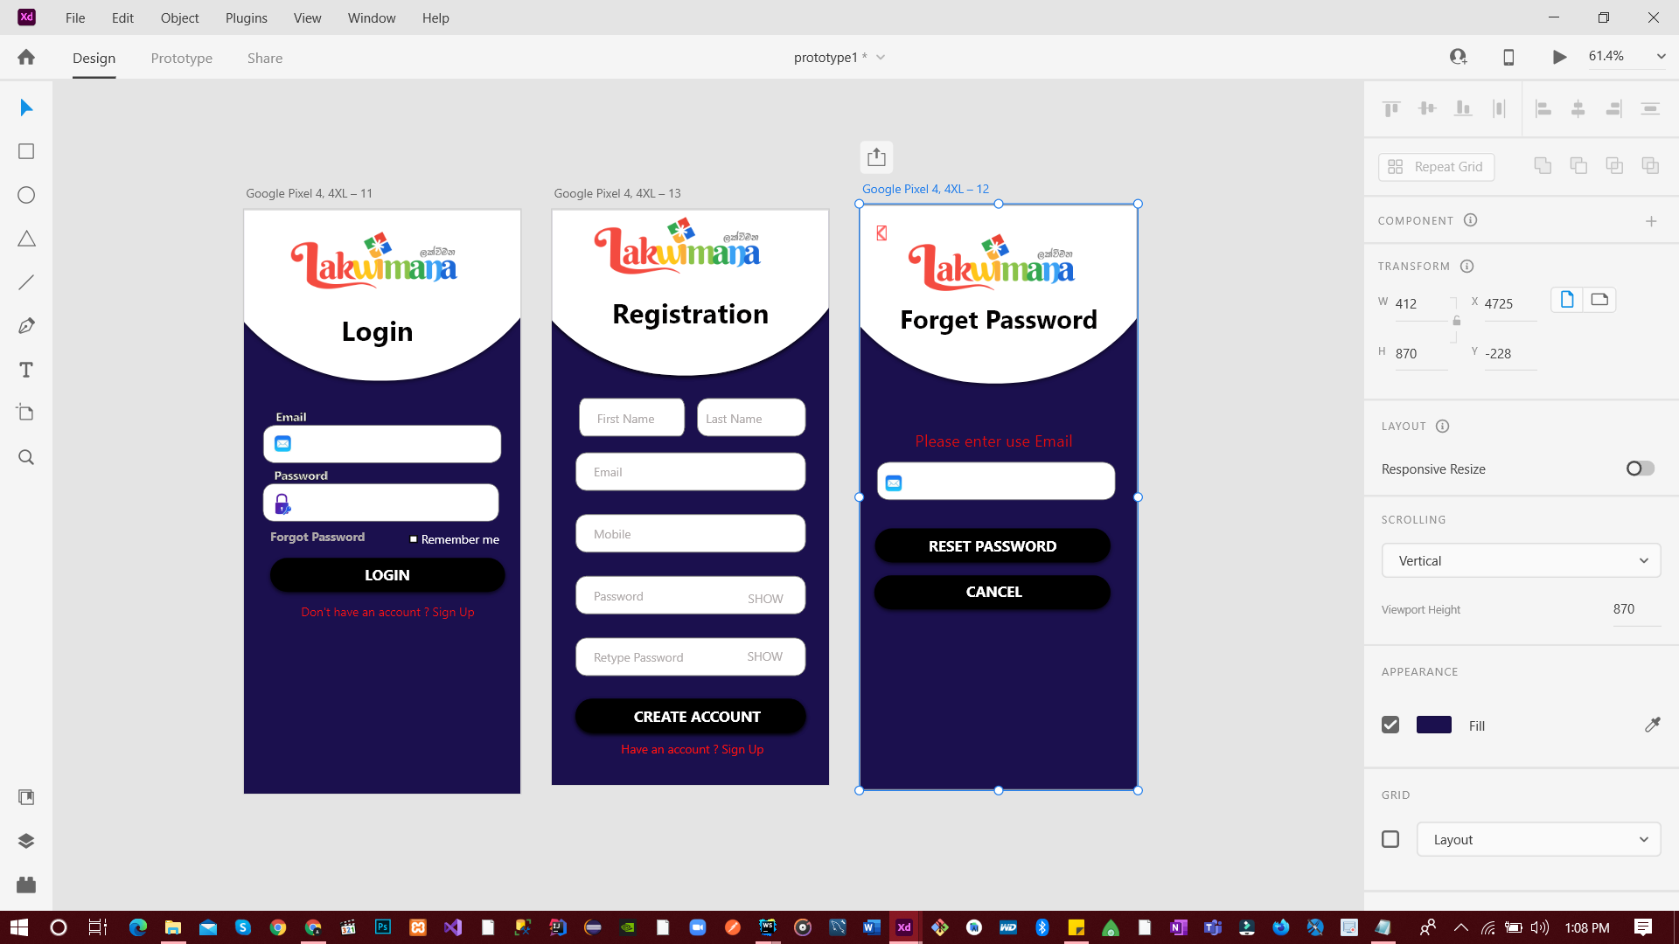

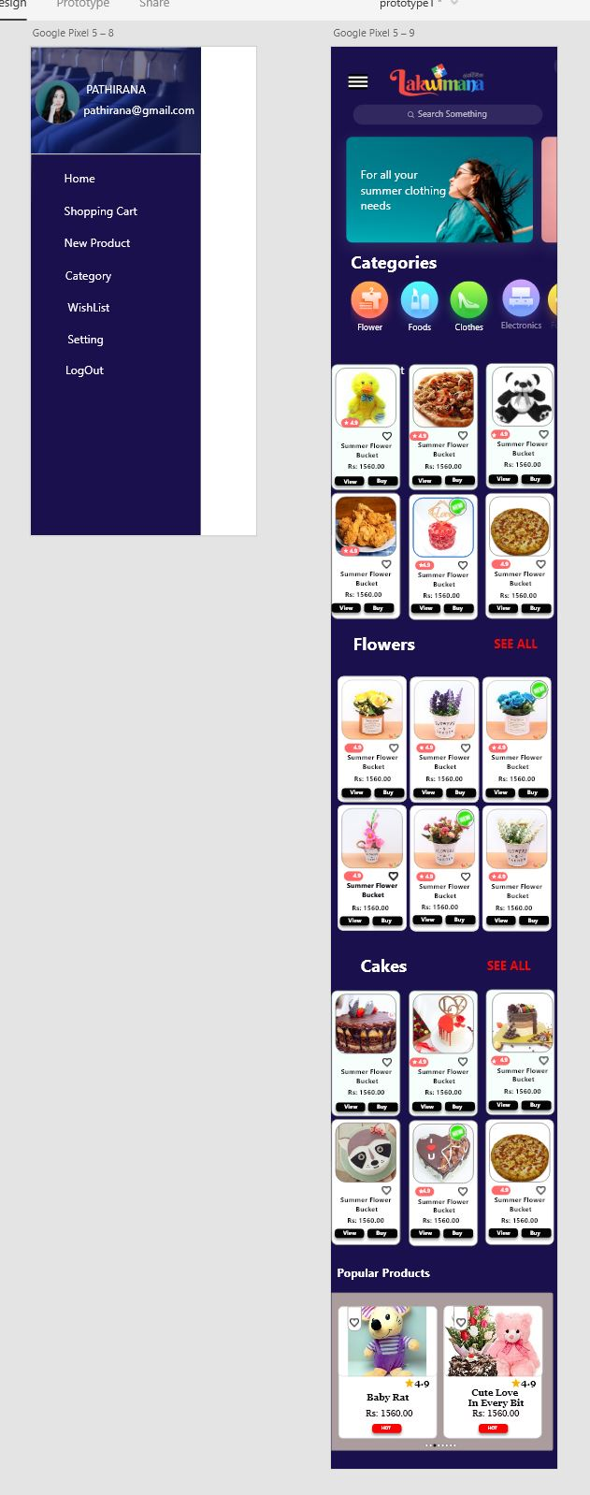

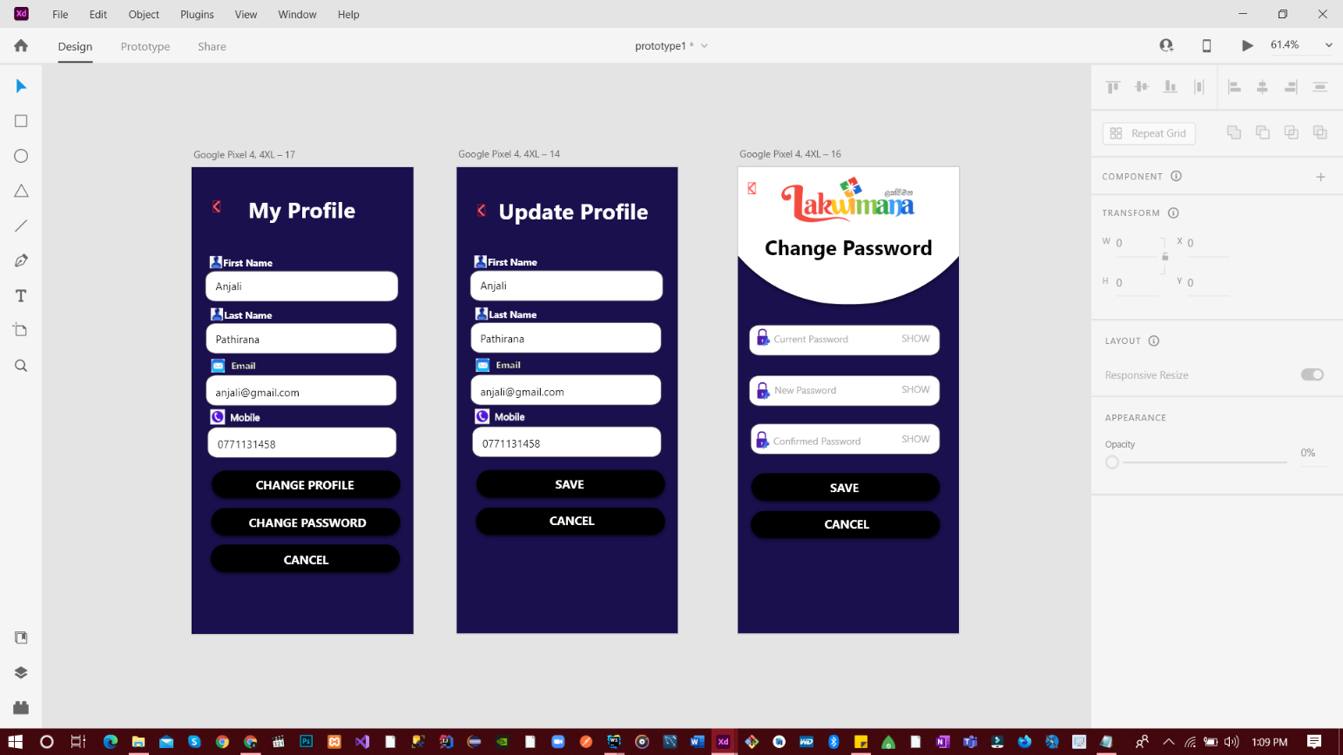

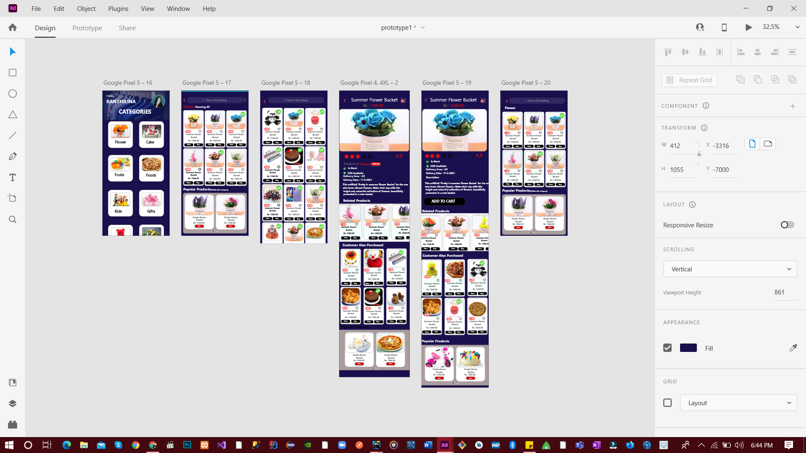

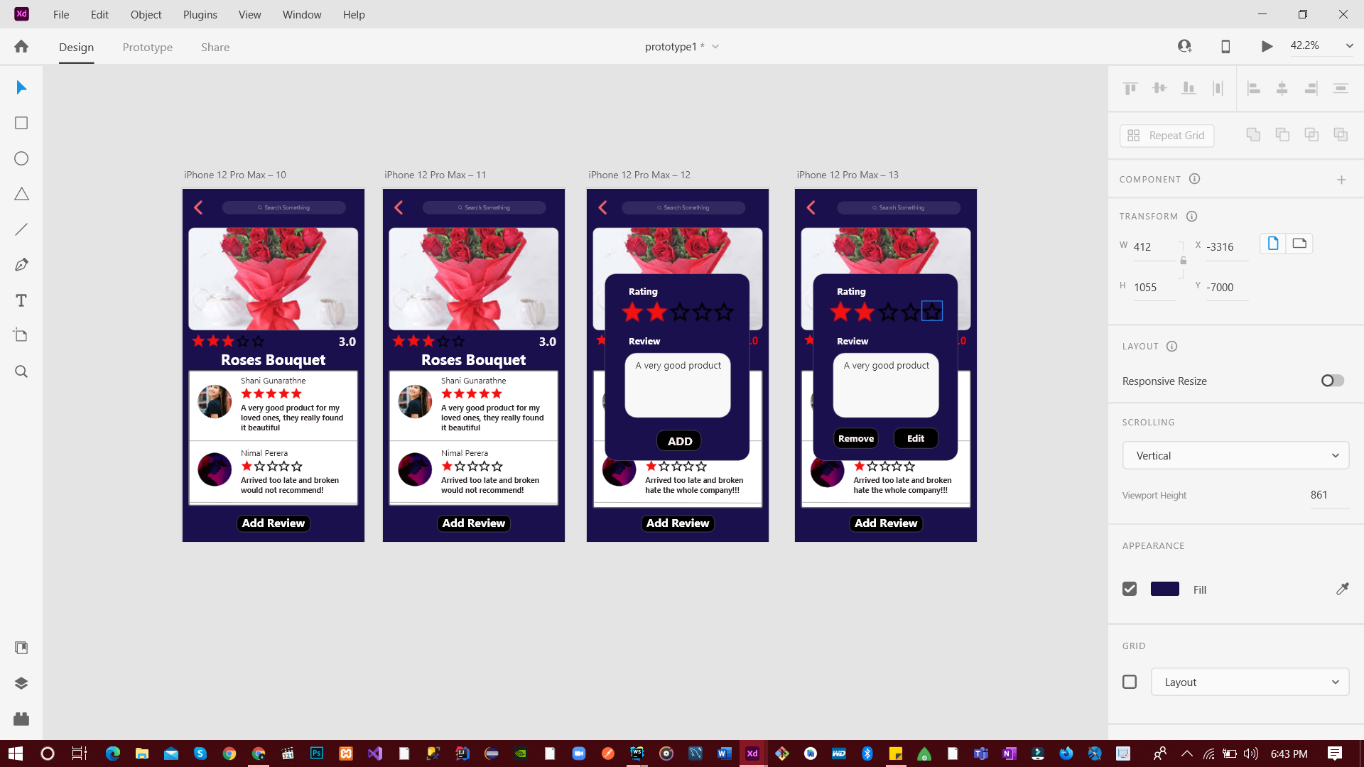

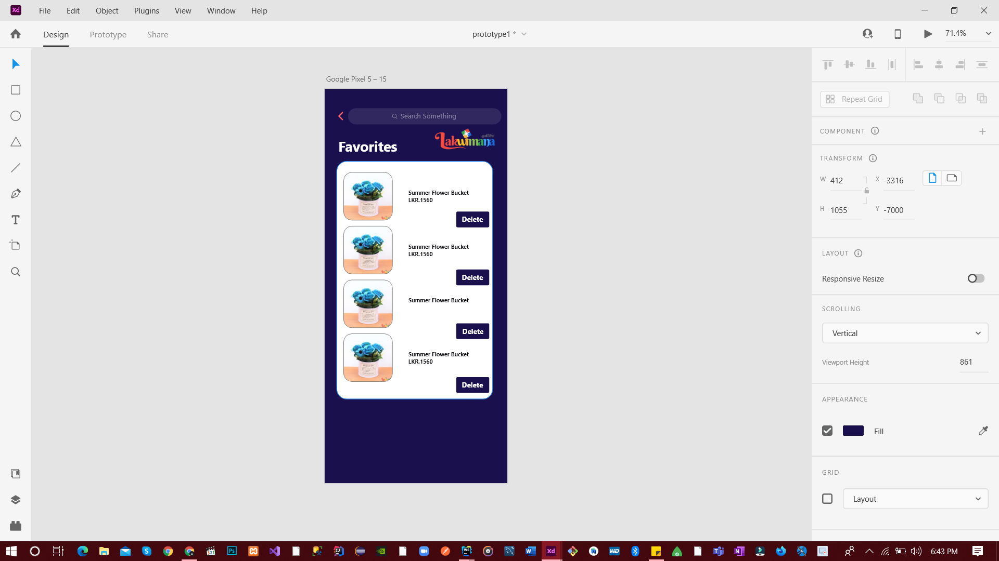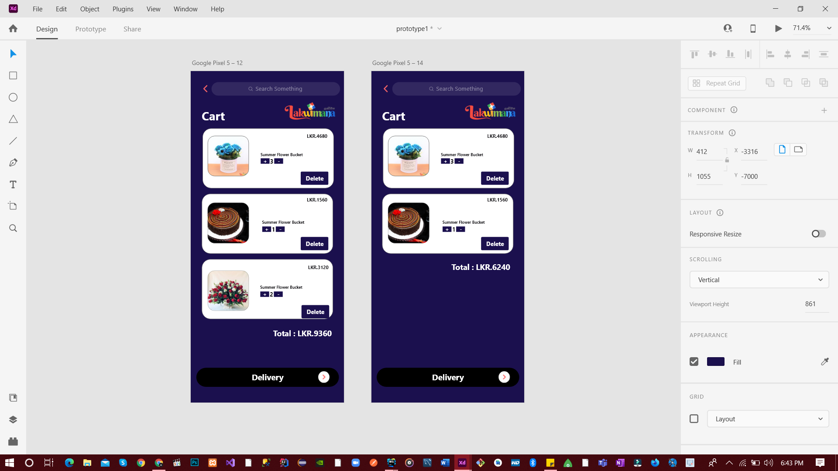

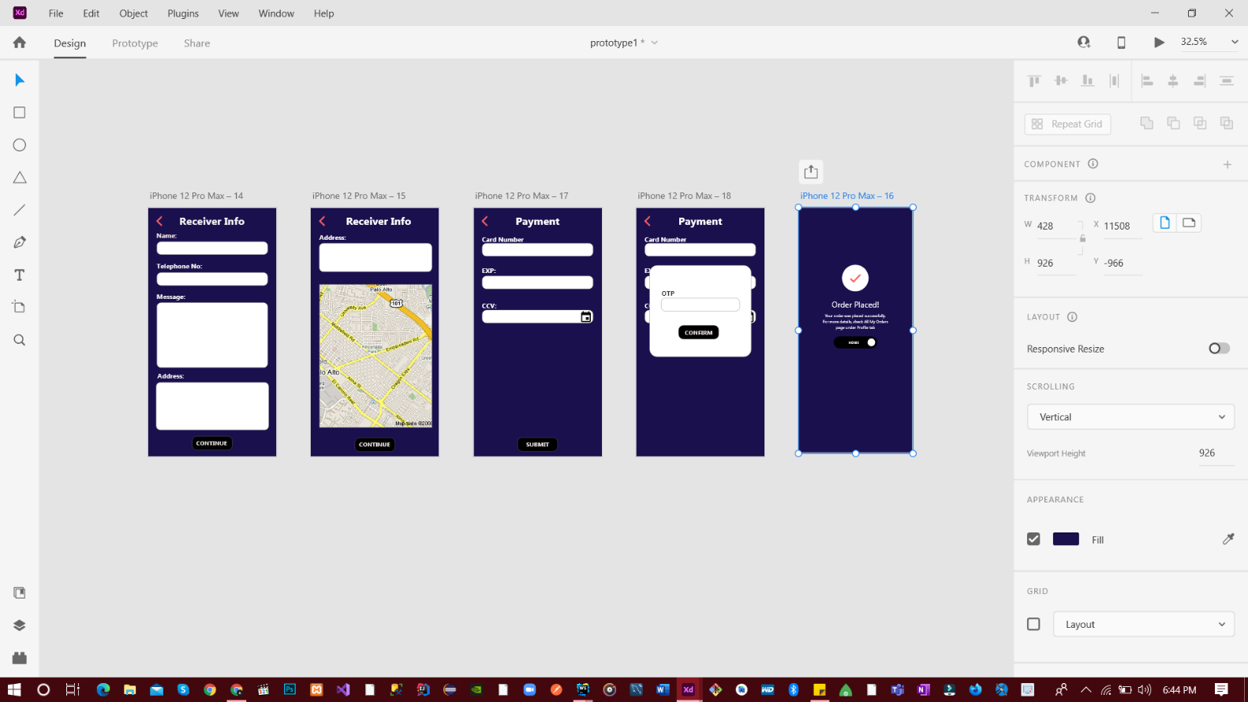

**4.** **User Feedback**

**4.1** **User Test Script – 01**

Salika – Hello, Jenny Thank you for participating for the session even with your busy schedule. As you might remember jenny my name is Salika. This is my partner Umesh and he might also be familiar to you.

Umesh – Like wise jenny the pleasure is all ours. You might already know why you’re here. But to refresh your memory, we have created the prototype for our Lakwimana app and we want you to give your honest feedback by using the said prototype.

Salika – Have you received it jenny?

Salika – Can you go through the designed prototype at least two-time please?

Umesh – Okay jenny now that you have thoroughly gone through our prototype, can you explain what you have found as the major weaknesses of our application?

Salika – Can you further elaborate that?

Salika – Okay Jenny, the first process you had go through was the logging and registrations process. Did anything catch your eyes that were a miss? you can go through the process right now if you want.

Salika – That was a nice suggestion. Okay jenny you can continue.

Salika – Yes jenny it voluntary because we thought that our application does not need profile picture for the users. Do you think we need one?

Umesh – All right Jenny now to the Product part of the prototype.

Umesh – Then now you can go to the product page, as you previously mentioned we have taken the suggestion of making product be bigger. is there anything else that you like to mention?.

Umesh- Is that all Jenny?

Umesh- Okay Jenny your feedback has enlightened us well.

Salika- Thank you once again Jenny hope that the rest of your day will be productive.

Umesh- Likewise Jenny have a wonderful day.

**4.2 User Test Script – 02**

Binuka – Hello, Rasith Thank you for participating for the session even with your busy schedule. As you might remember Rasith my name is Binuka. This is my partner Yasoja and he might also be familiar to you due to our previous interview.

Yasoja – Like wise Rasith the pleasure is all ours. You might already know why you’re here. But to refresh your memory, we have created the prototype for our Lakwimana app and we want you to give your honest feedback by using the said prototype.

Yasoja – Have you received it Rasith?

Binuka – Excellent, Now we want you to use go through it maybe twice in front of us?

Yasoja – Okay Rasith now that you have thoroughly gone through our prototype, can you explain what you have found as the biggest fault of our application according to your judgment?

Yasoja – Do you have any suggestions to make it better?

Binuka – Okay Rasith now we will go to individual functions. First is the cart and wish list. Can you go to it now and give your thoughts on them?

Binuka – That was a nice suggestion. Okay Rasith you can continue.

Binuka – We did not think of it. That was an excellent suggestion.

Yasoja – All right Rasith now to the Product part of the prototype.

Yasoja – Then now you can go to the Review and Delivery, Like before is there anything you would like to say looking at Reviews page first?

Yasoja - You can go back by clicking the background around the popup Rasith.

Yasoja - I will take a look in to that Rasith. Then the delivery.

Yasoja - I did not think of that before. I will write that down as well. Okay Jenny we have come to the end of the session and your feedback has enlightened us well.

Yasoja - Thank you once again Rasith hope that the rest of your day will be productive.

Binuka - Likewise Rasith have a wonderful day.

video evidence :

<https://drive.google.com/file/d/1OMKHJCmxz-Cx87EWR9tizhLOxo32bjsZ/view?usp=sharing>

Also available in the Lab -06 :Branch

**5.** **Prototype** (Version 2.0)

